Software Requirements Specification Template

Bearcat Furniture Hub

Software Requirements Specification

1.0.0

05/24/2023

Gollamudi Mahima Chowdary (S555087)

Mallela Mamatha (S555620)

Mallela Gautam Sagar (S555619)

Pilli Sanjay Kumar (S556374)

Yarapathineni Sai Tejaswini (S554224)

Submitted in partial fulfilment
Of the requirements of
CSIS 44-691 Graduate Directed Project 1

Revision History

Date | Description | Author | Comments
<date> | <Version 1> | <Your Name> | <First Revision>

Document Approval

The following Software Requirements Specification has been accepted and approved by the following:
Signature | Printed Name | Title | Date

Table of Contents

Table of Contents Page Number

- Introduction
  - Purpose
  - Scope
  - Definitions, Acronyms, and Abbreviations
  - References
  - Overview
- General Description
  - Product Perspective
  - Product Functions
  - User Characteristics
  - General Constraints
  - Assumptions and Dependencies
- Specific Requirements
  - External Interface Requirements
    - User Interfaces
    - Hardware Interfaces
    - Software Interfaces
    - Communications Interface
  - Functional Requirements
  - Use Cases
  - Class/Objects
  - Non-Functional Requirements
3.5.1. Performance
3.5.2. Reliability
    - Availability
    - Security
    - Portability
  - Inverse Requirements
  - Design Constraints
  - Logical Database Requirements
  - Other Requirements
  - Prototypes (for complete project)
  - Use Case Diagrams
- Design
4.1. ER diagram
4.2. GUI
- Analysis Models
4.1. Data Flow Diagram
4.2. Sequence Diagram

- Introduction
A Bearcat furniture Hub is a marketplace application software platform that allows students to give and take furniture. The application can be used by both givers and takers, and it provides a variety of features to make the giving and taking process easier.

  - Purpose
The purpose of a Bearcat furniture Hub marketplace application is it connects students within the Northwest Missouri State university to facilitate the exchange of used furniture. The application provides a variety of features to make the giving and taking process easier.

  - Scope

The scope of this project is to develop a web application for students of the Northwest Missouri State university to exchange their used furniture. The application will allow students to post their furniture items, search for items based on keywords and request items from other students. The application will have a chat feature for communication between the giver and taker. The web application will be developed using the MERN stack.
  - Overview
A web application for students of the same university to exchange used furniture. The aim is to facilitate the transfer of furniture from students who are leaving the campus after completing their studies to those who are in need of it. By using the MERN stack, the givers can post details and pictures of the furniture they wish to give away, while the takers can browse through the listings and contact the givers via a chat feature. This way, both parties can benefit, with the givers saving money on transportation and finding interested takers easily, while the takers can obtain required furniture items with ease.

- General Description
  - Product Perspective
The product perspective is that it provides a sustainable and cost-effective solution for students who are leaving campus to dispose of their furniture while providing an opportunity for other students to obtain furniture. Givers can easily post details and images of their furniture, while Takers can browse and contact Givers using a chat feature. The web application is developed using MERN stack and benefits both Givers and Takers by saving transportation costs and providing access to used furniture.
  - Product Functions
- User Registration and Authentication: Users should be able to create accounts and log in securely to access the platform.
- Product Listings: Givers should be able to post details and images of their furniture items, including information like age, condition, and any additional notes.
- Search: Takers should be able to search for furniture items based on various criteria such as keywords to narrow down their search.
- Product Details and Images: Takers should be able to view detailed information about a specific furniture item, including multiple images to get a better understanding of its condition and appearance.
- Chat Functionality: Implement a chat feature to allow takers and givers to communicate and discuss further details about the furniture item, negotiate terms, and arrange for pick-up or delivery.
- User Profile: Users can view their details here.
  - User Characteristics
- Students of the same university who are in need of furniture.
- Students of the same university who are leaving the campus after their studies and want to give away their used furniture.
- Students who are environmentally conscious and want to reduce waste by reusing furniture.
- Students who are cost-conscious and want to save money by obtaining furniture for free.
- Students who are willing to communicate with potential givers/takers through the chat feature to finalize the exchange.
  - General Constraints
- The web application should have strong security measures to ensure that user data, including personal information and chat messages, are kept private and secure.
- To maintain trust and reliability in the platform, users should be verified using their university email.
- The web application should be available and scalable to handle a large number of users and furniture listings.
- The user interface should be easy to use, intuitive, and responsive to ensure a positive user experience.
- The web application should have ongoing maintenance and support to ensure that it remains secure, up-to-date, and functional.

  - Assumptions and Dependencies
Assumptions
- The students who use the web application are honest and provide accurate information about the furniture they post.
- The furniture being exchanged is in good condition and does not pose any safety hazards.
- The students who use the web application are willing to communicate with each other through the chat feature to finalize the exchange.
- The students who use the web application are able to meet in person to exchange the furniture, and they will take necessary precautions to ensure their safety.
Dependencies
- The web application is dependent on the availability of an internet connection and a device to access it, such as a computer or a smartphone.
- The web application is dependent on the MERN stack (MongoDB, Express, React, Node.js) for development.
- The web application is dependent on the hosting platform and server for deployment and accessibility.
- The success of the web application is dependent on the willingness and participation of the students to post and exchange furniture through the platform.

- Specific Requirements
3.1. External Interface Requirements
3.1.1 User Interfaces
We are designing a user interface with the help of HTML,CSS,Javascript and React JS framework.
3.1.2 Hardware Interfaces
- Processor: 1.6 GHz or higher
- RAM: 4 GB or higher
- Hard disk space: 10 GB or higher
- Operating system: Windows 7, 8, or 10; Mac OS X 10.9 or higher; or any modern Linux distribution
- Internet connection: Required for downloading dependencies and packages using package managers like npm or yarn.
3.1.3. Software Interfaces
We are developing our application with the MERN Stack (MongoDB, Express.js, Node.js and React).
3.1.4. Communications Interface
The Communication Interface which is used for the project is Web browser.

3.2 Functional Requirements
Functional Requirements for Giver
- The giver should be able to create an account on the platform to post the furniture.
- The giver should be able to post the details and pictures of the furniture they wish to give away, including the furniture's condition, age.
- Giver should be able to edit their furniture post and update any details as needed.
- Giver should be able to delete their furniture post if the furniture is no longer available or if they change their mind about giving it away.
- The giver should be able to communicate with takers who are interested in their furniture through a chat feature within the web application.
- The giver will be able to view the items donated.
Functional Requirements for Taker
- Taker should be able to create an account on the platform to browse the furniture listings.
- Taker should be able to search for furniture by keyword to find the furniture they need.
- The taker should be able to view the details and pictures of the furniture posted by the givers, including the furniture's condition, age.
- Taker should be able to send a request to the giver to express their interest in the furniture.
- Takers should be able to cancel their request if they change their mind or if they find another furniture item they prefer.
- Taker should be able to communicate with the giver through a chat feature within the web application to negotiate and finalize the exchange.
- Taker will be able to view the requests placed for the furniture.
3.3 Use Cases
- A student who is leaving campus after completing their degree can use the web application to post details and images of their furniture, such as a couch, a bed, or a desk, that they no longer need.
- A student who is in need of furniture can use the web application to search for and browse available furniture items posted by other students.
- Once a student has found an item they are interested in, they can use the chat feature to communicate with the giver and ask any questions they may have about the item.
- After agreeing to take an item, the taker can schedule a pickup time and location with the giver using the chat feature.
3.4 Classes/Objects
We will create the classes accordingly once we start implementation of the project.
3.5 Non-Functional Requirements
3.5.1 Performance
The web application should be fast and responsive, with minimal loading times and quick search to ensure a seamless user experience.
3.5.2. Reliability
The web application should be reliable, with minimal downtime and errors, to ensure that users can access the platform whenever they need to.
    - Security
The web application should be secure, with proper measures in place to prevent unauthorized access, data breaches, and other security risks.

  - Inverse Requirements
- The system should not allow users to post inappropriate or offensive content.
- The system should not be used for commercial purposes, such as selling furniture.
- The system should not be used to request or offer furniture that is not located within the same university.
- The system should not be responsible for any issues arising from the exchange of furniture between users, such as damage or misrepresentation of items.
  - Design Constraints
- The application should be designed with strong security measures in place to prevent unauthorized access to user data.
- The interface should be easy to use, with clear navigation and user-friendly features.
- The application should be designed to accommodate potential growth in the number of users and amount of data.
- The application should be designed to work on a variety of web browsers to maximize accessibility.
- The application should be optimized for fast loading times and smooth performance, even with multiple users.
  - Logical Database Requirements
- The database should be optimized for fast and efficient data retrieval and processing.
- The database should have a backup and recovery plan.
3.10 Prototypes (for complete project)
Landing Screen:
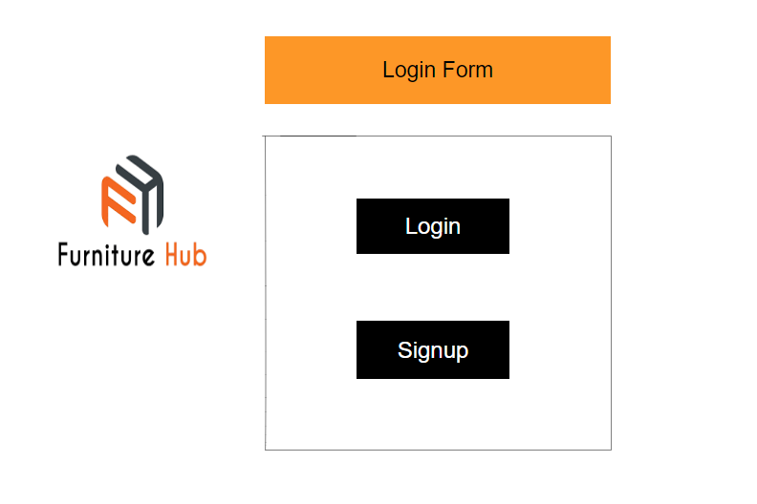

Login Screen:
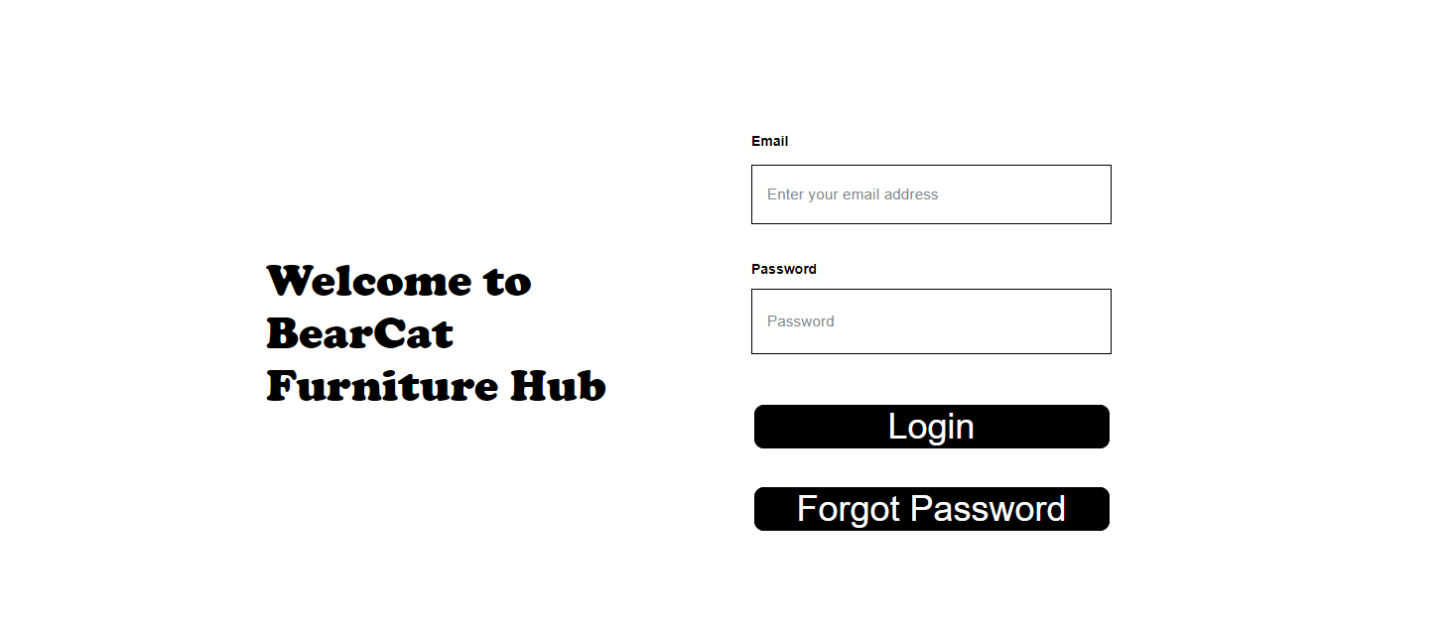

Signup Screen:
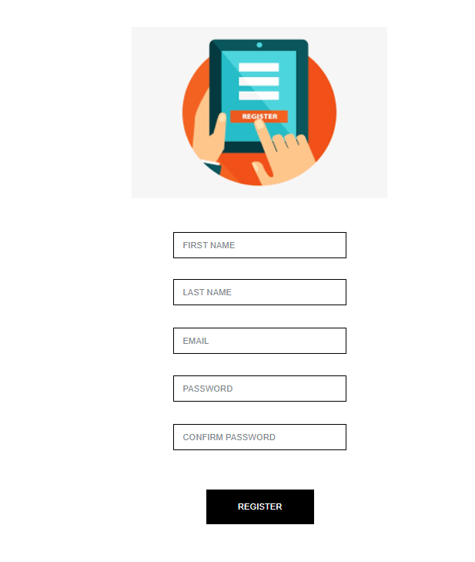

Home Screen:
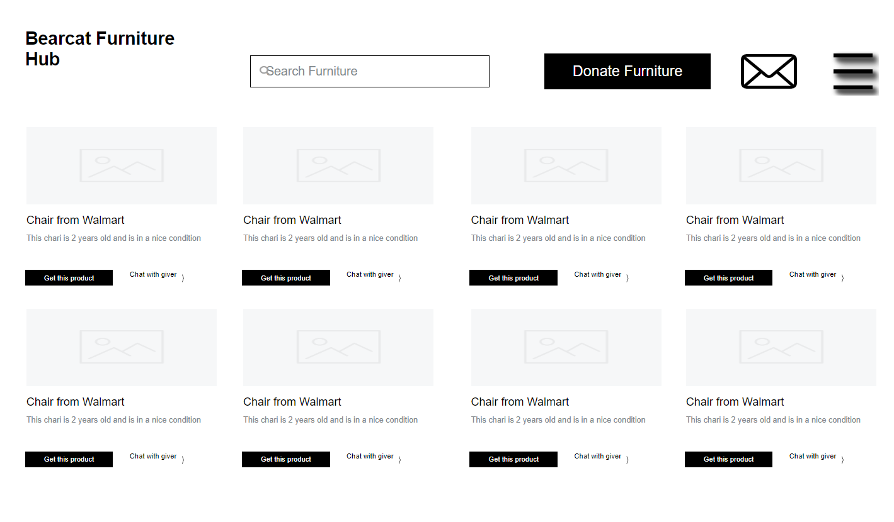
Profile Screen:
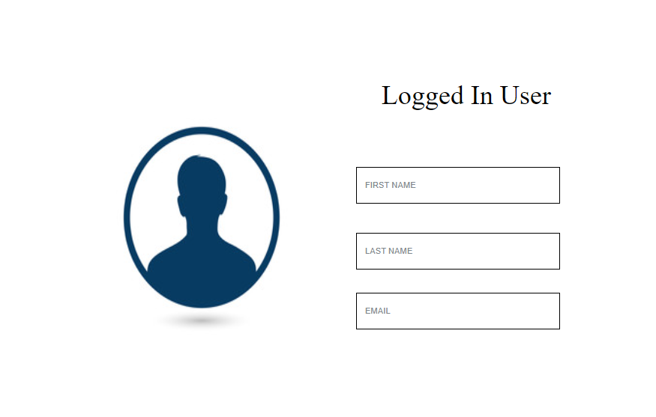

Donate Screen:
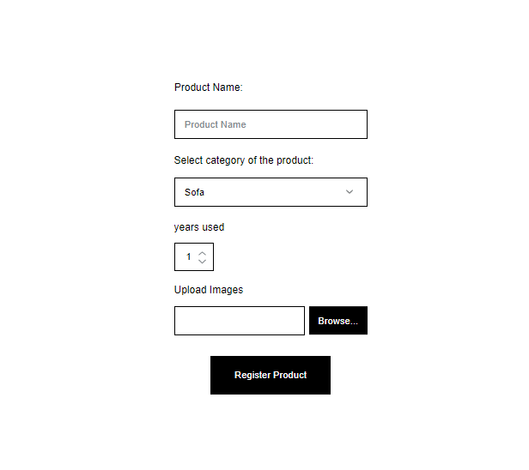

Product Screen:
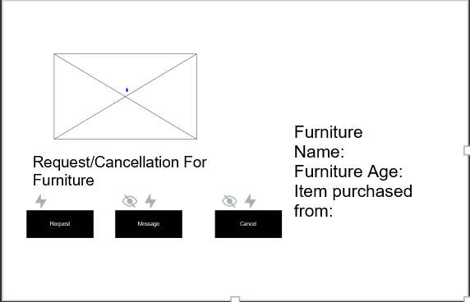

Dashboard Screen:

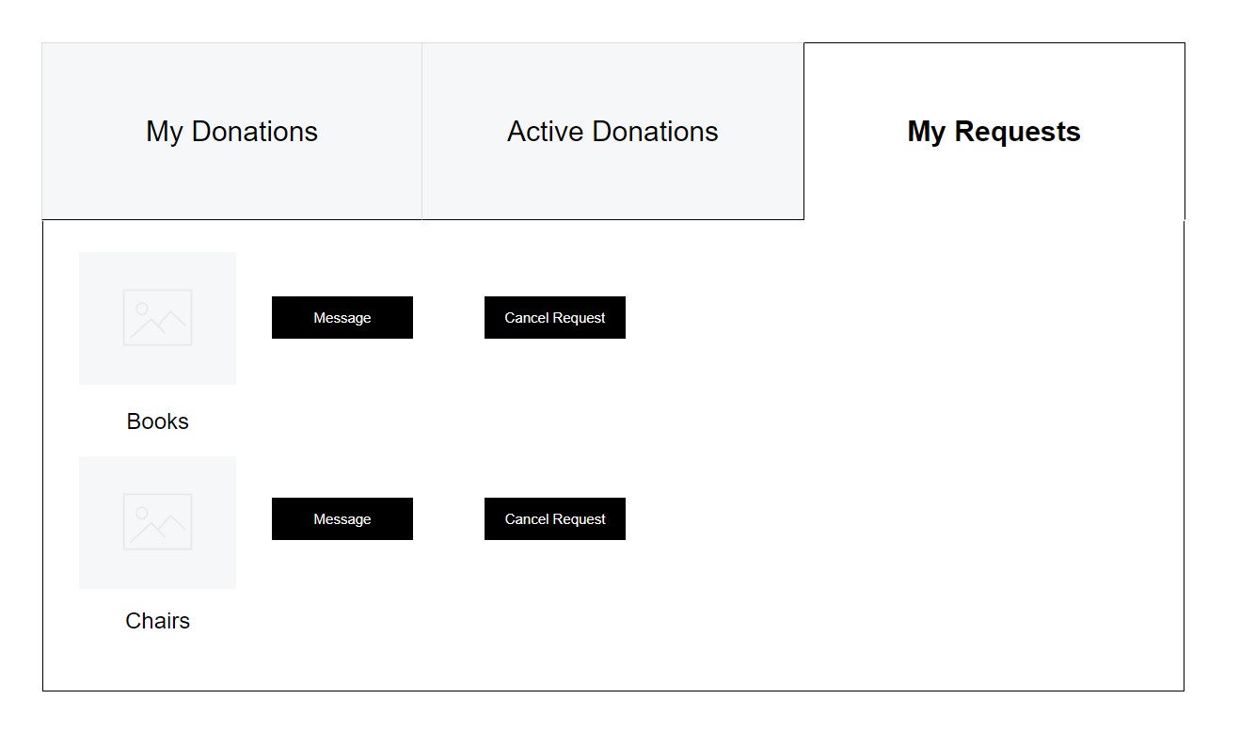

3.11. Use Case Diagrams
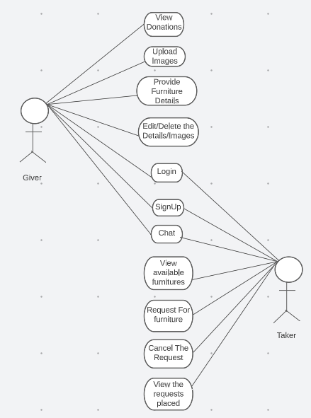
4.Design
4.1. ER diagram

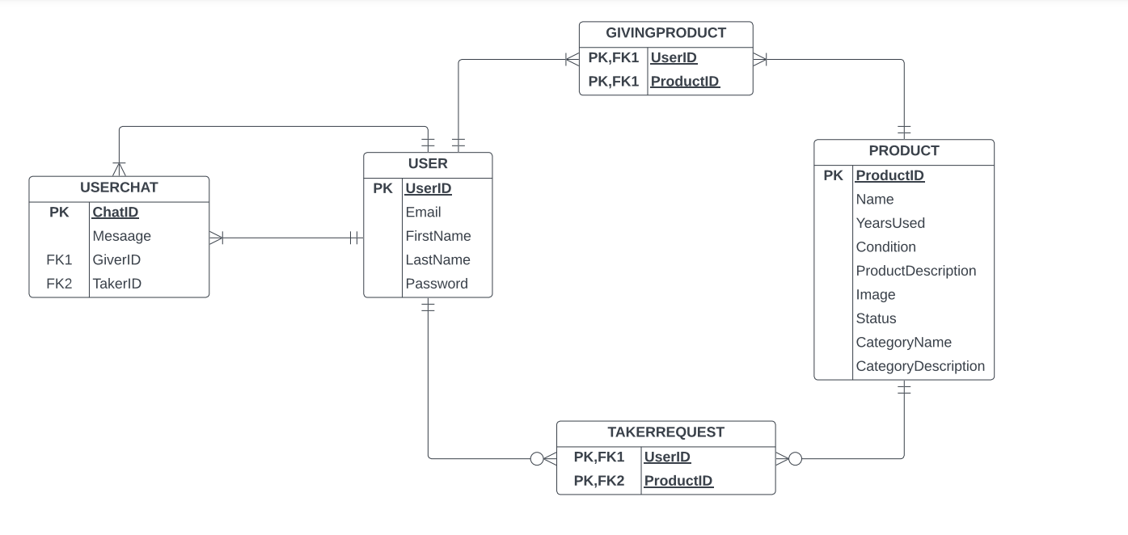

4.2 GUI
1. Login Page
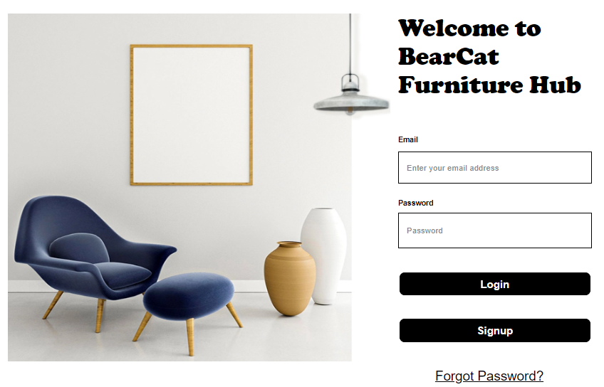

2. Signup Page

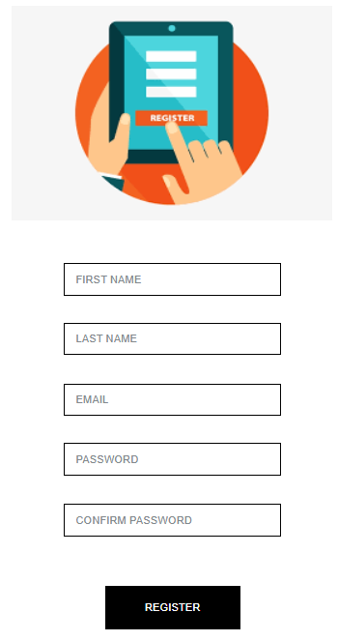
3. Home Page
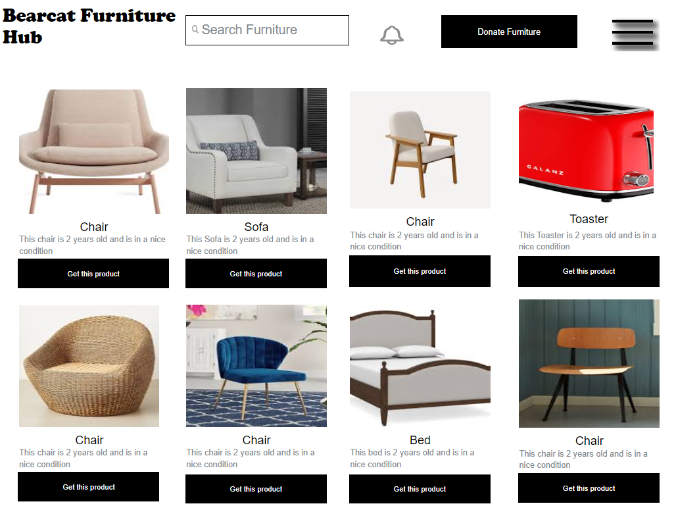
- Donate Page
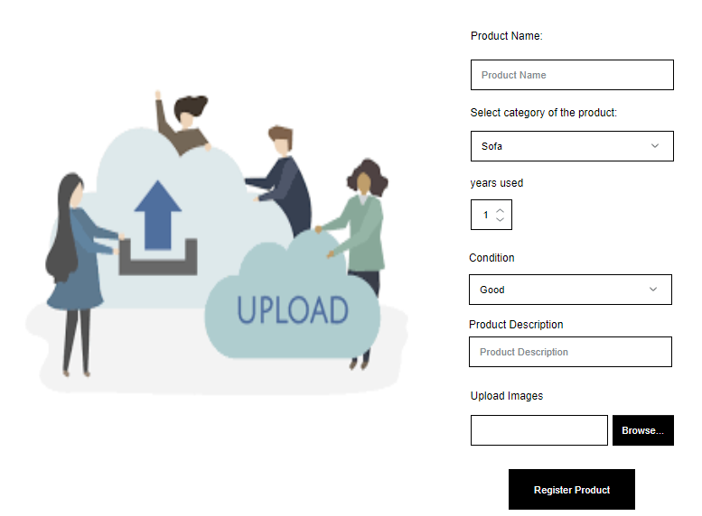
- Product Detail Page
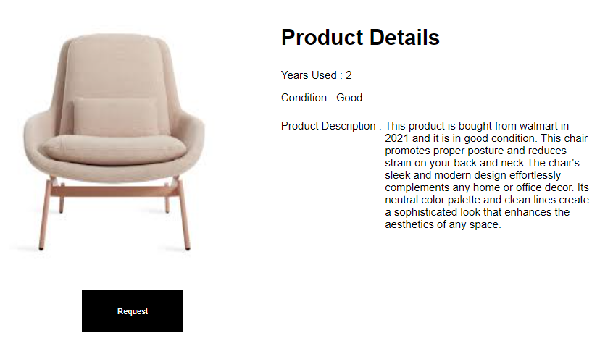

- Dashboard Page
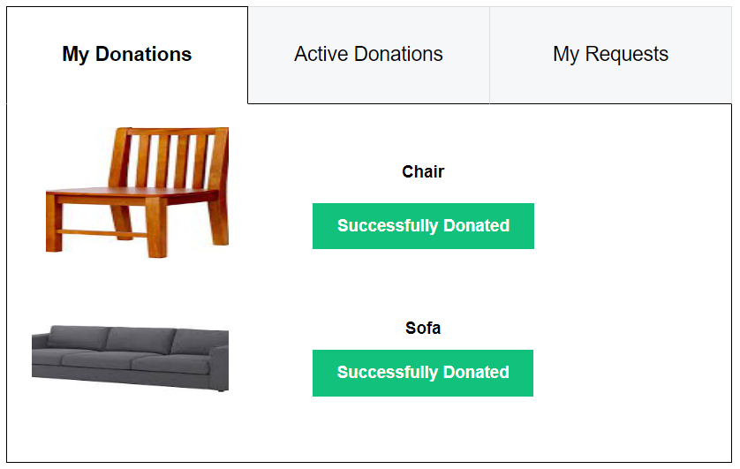

- Profile Page
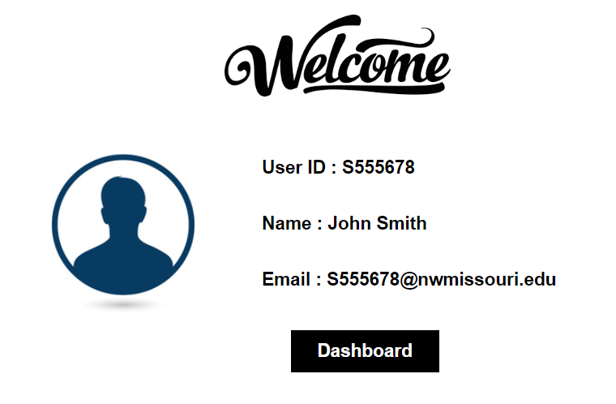

- Chat Page
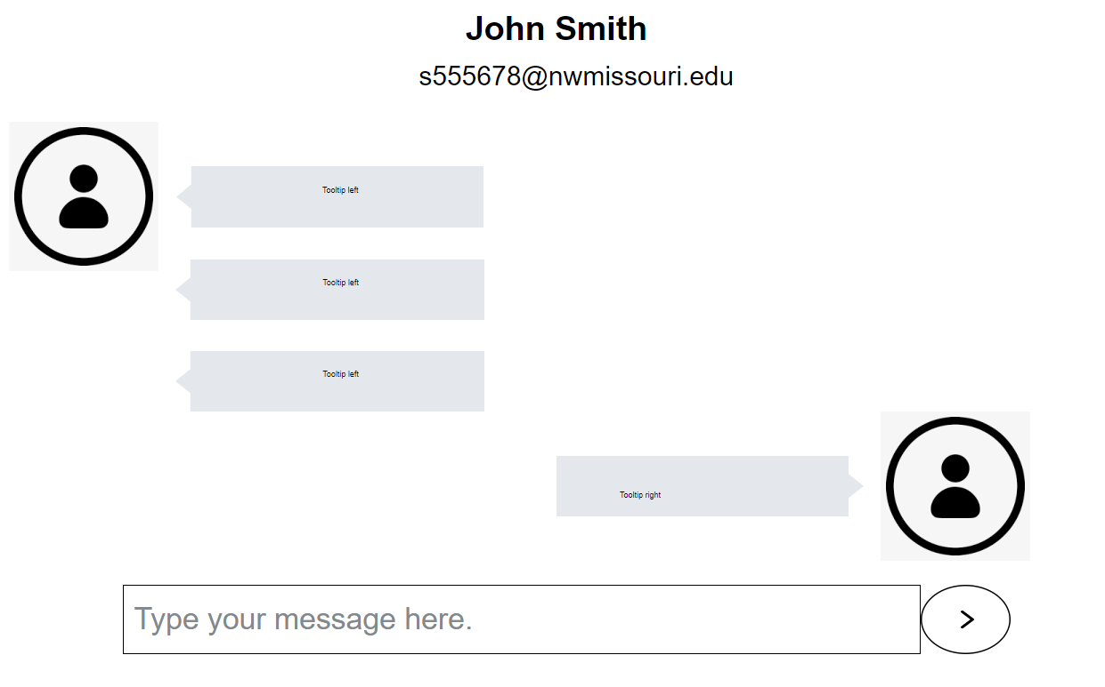

5. Analysis Models
5.1. Data Flow Diagram
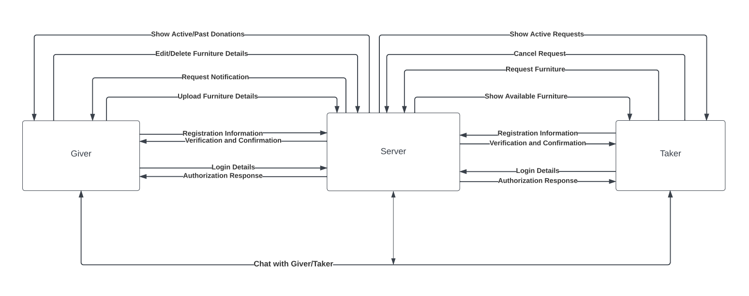

4.2 Sequence Diagram

